**SQL Assignment – Evening Session**

Name – Aagam Shah

Email- [Aagam.shah@accolitedigital.com](mailto:Aagam.shah@accolitedigital.com)

Batch – 2 (Bangalore)

For Cricket world cup Database we have selected 3 tables –

1. Players
2. Match_Played / Points Table
3. Matches

Here Player store the player data

|  |  |  |  |  |  |  |
| --- | --- | --- | --- | --- | --- | --- |
| P_Id | P_Name | P_Type | Runs_Scored | Wicket_Taken | Match_Played | Team_Name |
| int | Varchar(20) | Varchar(20) | int | int | int | int |

P_Id : Player ID

P_name : Player Name

P_type : Batsman / Bowler

Runs_Scored : Runs scored by player

Wicket_Taken : Wicket taken by player

Match_Played : Matches played by player

Team_Name: Name of Team Player plays for

Assumptions

1. Players do not play all the matches played by the team
2. If player is a batsman / bowler he can do both of the following in case of extreme situation

Match_Played acts like the points table for the

|  |  |  |  |  |  |
| --- | --- | --- | --- | --- | --- |
| T_id | Team_Name | M_played | M_won | Total_Runs | Total_Wicket |
| Int | Varchar(20) | int | int | int | int |

T_id : Team Id

Team_Name : Team name

M_played : Matches played

M_Won : Matches won

Total_Runs : Total runs scored by the team

Total_Wickets: Total Wickets taken by the team

Match Table stores the score of each match

|  |  |  |  |
| --- | --- | --- | --- |
| M_id | T_id | Runs | Wickets |
| Int | Int | Int | int |

M_id : Match Id

T_id : Team Id (Foreign Key from Match_Played Table)

Runs : Runs scored in each match

Wickets: Wickets taken in each match

Output of the Queries

Query a: Create sample data in all the tables.

Query b: Fetch the top 5 batsmen who scored the maximum runs.

select * from players where p_type='batsman' order by run_scored desc limit 5;

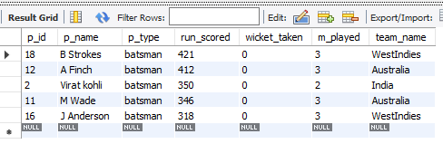

Query c: Fetch the top 5 bowlers who has taken the maximum wickets.

select * from players where p_type='bowler' order by wicket_taken desc limit 5;

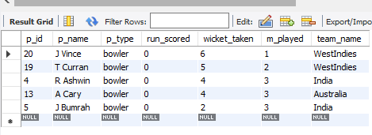

Query d: Fetch the average score scored by each team considering the matches played.

select team_name, total_runs/m_played as average from match_table order by total_runs/m_played;

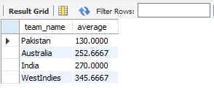

Query e: Increase the scores of each batsmen in the team, which has the least average computed in Step 6, by 10 runs.

Since Pakistan has the lowest average hence we update Pakistan’s data

SET SQL_SAFE_UPDATES = 0;

update players set run_scored = run_scored + 10 where team_name =

( select team_name from match_table order by total_runs/m_played asc limit 1);

select * from players where team_name = 'Pakistan';

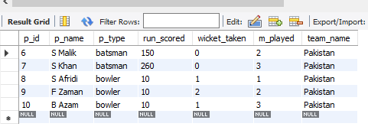

Query f: Create a procedure which takes country as the input and gives the highest score of the country up to date, as output

DELIMITER $$

drop procedure if exists highest_score$$

create procedure highest_score(team_name_input varchar(50), out highestScore int)

begin

select max(runs_scored_in_match) into highestScore from matches join match_table on matches.t_id = match_table.t_id where match_table.team_name = team_name_input;

end$$

DELIMITER ;

call highest_score('India',@highestScore);

select @highestScore;

